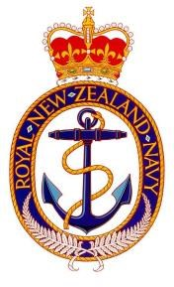

Royal New Zealand Navy

The Ruth Slight Memorial Trophy

Citation

ACWS Moore started his Leading Communications Warfare Specialist (Q) course on the 15th June 2020. During the course it was recognised by Instructors that Moore was someone who understood the leadership framework and actively sought opportunities to practice and demonstrate the ‘Lead Teams’ tools. Moore thrives on feedback and is continuously seeking ways to develop his leadership style, and improve his feedback techniques, Moore considers feedback to be a powerful and important aspect of leadership and proactively attempts to get it right in order to empower his team, instructor’s, and class members.

*ACWS Moore joined the RNZN as an OET, due to medical circumstances Moore was unable to achieve an overall pass of the exams in basic branch training and his desire to continue his career in the ET trade had to discontinue. Despite this he is thriving in the CWS trade and is well supported to strive for excellence as he continues to progress in his career. His courage, commitment, and integrity has been thoroughly tested through his trade transition and his unique journey undertaken in the CWS trade.*

*ACWS Moore is highly motivated, he takes the initiative to learn from experiences and filters the expertise from influencers around him, absorbing the skill sets and behaviours that he believes will add value to his leadership development, particularly with regard to communication and personable skills.*

*He has an amazing interpretation of the communications systems he has worked with and he is very good at explaining them to his course members without hesitation catering to different learning styles and being comfortable to engage in the opportunity to express his competence as an ACWS, which has enabled him to gain respect from his peers. Moore is eager and confident in volunteering, and putting in extra effort to ensure his fellow class members could understand what was being articulated by the instructor.*

*ACWS Moore is therefore awarded the Ruth Slight Memorial Cup for the most Outstanding CWS Student for 2020.*

*BZ*