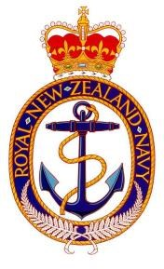

Royal New Zealand Navy

James Dell Cup

Citation

POCWS Tatana joined Te Kaha in 2019 providing valuable service to the ship leading a small team of operators, representing the trade and acting as its Subject matter expert in an isolated situation, with no immediate supervision or support available.

She re-deployed with the bulk of the ship crew in June 2020. Her first ship posting with a full crew as a petty officer.

Being one of the few operators with ANZAC experience, PO Tatana quickly developed a program of training and coaching to impart her knowledge of the ships remaining legacy systems. Also, in Coordination with the Senior Comms rate she began to build a new culture and mentality that has been missing with the ANZAC class being absent from the fleet for a lengthy period. This was a culture of professionalism and pragmatism. Allowing subordinates to exercise initiative and try out new ideas to further progress the department. PO Tatana displayed and championed this culture on a daily basis.

PO Tatana has a calm and resolute leadership style. Providing structured lessons and an approachable coaching nature. She balances the needs of the individual and the needs of the mission and team with a tact belying her time in rank.

Through her efforts and guidance all communications systems that can be brought online are functioning and moral throughout the department is solid and upbeat.